MyRestro Website Documentation
Live Demo: https://agmarestorant.netlify.app/

**1. Code Structure Overview
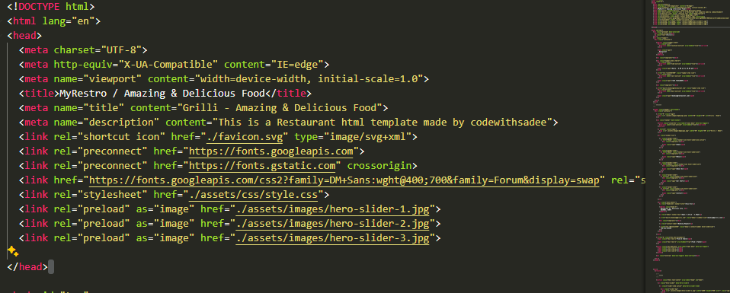
Key Components:
- Header & Navigation:
  - Logo (<a href="#" class="logo"> with AgmaLogo.png).
  - Mobile-responsive menu toggle (data-nav-toggler attributes).
  - Navigation links (#home, #menu, #about anchored to sections).
- Hero Slider:
  - Auto-rotating image carousel (<ul class="hero-slider">).
  - Preloaded images (<link rel="preload" as="image" ...> in <head>).
- Sections:
  - Services: Breakfast/Appetizers/Drinks cards (<section class="service">).
  - About Us: Story section with parallax effects (data-parallax-item).
  - Menu: Grid of dishes with prices (<section class="menu" id="menu">).
  - Reservation: Interactive booking form (<section class="reservation">).
  - 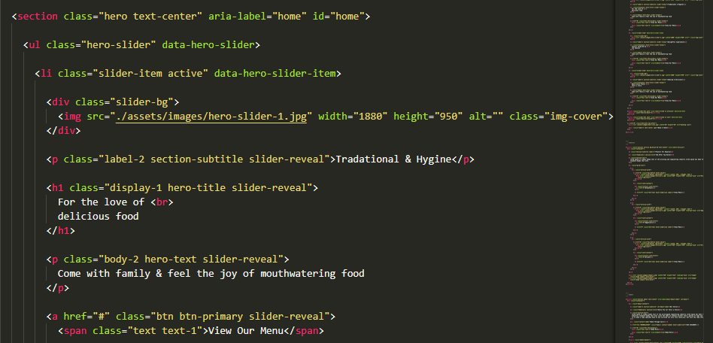
- Footer:
  - Newsletter subscription form.
  - Social media links .
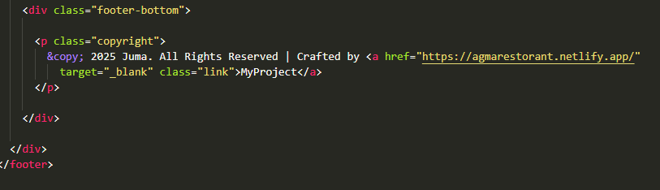

2. Deployment (Netlify)
Step 1: Prepare Code
- Ensure all assets (images, CSS, JS) are in the assets/ folder.
- Update contact details in:
html
Copy
Download
Run
<!-- In Topbar -->
<a href="tel:+254743418889">+254 743418889</a>
<a href="mailto:booking@restaurant.com">booking@restaurant.com</a>
Step 2: Deploy via Netlify
- Drag-and-Drop:
  - Zip your project folder → Upload to Netlify.
- Git Deployment:
  - Connect your GitHub/GitLab repo → Set build settings:
    - Build command: Leave empty.
    - Publish directory: / (root).
Step 3: Configure Netlify Forms
Add these attributes to the reservation form (<form>):
html
Copy
Download
Run
<form action="/" method="POST" data-netlify="true">
<input type="hidden" name="form-name" value="reservation"
</form>
- Submissions will appear in Netlify’s Forms tab.

**3. Testing Guidelines
A. Functional Tests
- Navigation:
  - Test all anchor links (e.g., #home, #menu).
  - Verify mobile menu toggle (data-nav-toggler).
- Hero Slider:
  - Confirm auto-rotation and manual navigation (prev/next buttons).
- Reservation Form:
  - Submit test entries → Check Netlify Forms dashboard.
B. Performance Tests
- Lighthouse Audit:
  - Run in Chrome DevTools → Optimize images if score < 90.
- Responsiveness:
  - Test on mobile (e.g., iPhone SE) and tablet breakpoints.

**4. Customization Guide
A. Update Content
- Logo:
AgmaLogo.png in:
html
Copy
Download
Run
<img src="./assets/images/AgmaLogo.png" width="50" height="50" alt="...">
- Menu Items:
Edit dish cards in the <!-- #MENU --> section:
html
Copy
Download
Run
<li>
<div class="menu-card">
<img src="./assets/images/menu-1.png" alt="Greek Salad">
<h3 class="title-3">Greek Salad</h3>
<span class="span title-2">$25.50</span>
</div>
</li>
B. Modify Styles
- Override CSS variables in style.css:
css
Copy
Download
:root {
--background: #0c0c0c; /* Example variable */
}

**5. Troubleshooting
Issue | Solution
Images not loading | Confirm paths (e.g., ./assets/images/...).
Form not submitting | Add data-netlify="true" to <form>.
Mobile menu not closing | Check data-nav-toggler JS logic in script.js.

6. Credits & License
- Design Template: Adapted from codewithsadee.
- Icons: IonIcons.
- License: Free for personal use. Attribute the original author.

My site is live at https://agmarestorant.netlify.app/

